APPLICATION FORM
XVII INTERNATIONAL CONGRESS & WORKSHOP ON DRY STONE, Konavle, Croatia
‘’Dry stone perspectives: challenges after the UNESCO inscription’’
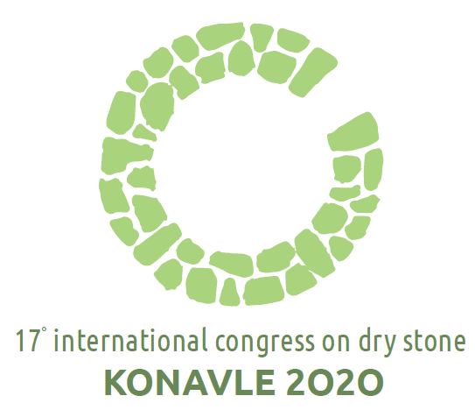

Workshop: September 28th - October 1st 2020
Congress: October 2nd - 4th 2020

Keep in mind
Deadline for registering as a speaker and/or poster exhibitor is until February 29th 2020. Deadline for registering as a listener only or workshop participant only is until June 30th 2020.
Organisers encourage registering as soon as possible. If the number of registrations overwhelms logistical capacities, registrations will be closed earlier than announced.
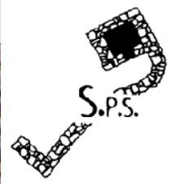
Please send the application filled out on the computer in Word format to contact@pierreseche-international.org and info@dragodid.org
Participation fees
Participation fee covers: admittance to all sessions with simultaneous translation during presentations (Croatian, English, French), access to working documents, coffee and refreshments during breaks, welcome cocktail(Oct 1st), closing dinner(Oct 3rd), field trip (Oct 4th).
Participating as workshop participant only does not require paying the fee. Number of places for workshop participants is limited.

Fees in Euros are:
 | 1 DAY | 3 DAYS
Participant | 80 | 170

Decreased fees in Euros for members of SPSand students:
 | 1 DAY | 3 DAYS
SPS member* | 50 | 140
SPS member* student | 50 | 80
Student | 80 | 120

* SPS member that is a legal entity can use the decreased fee (50/140, or 50/80) for only two of its representatives. All other representatives of entities that are members of the S.P.S. pay the full fee (80/170, or 80/120).

Payment details:
All fees are to be payed in Euros while registering, by bank account, with payment description: Congress fee - [name surname]

For SPS members:
Recipient:
Société Internationale Etude Pierre Sèche
Crédit Agricole Mutuel de Provence Alpes Côte d’Azur, Brignoles, France
IBAN: FR76 1910 6000 0208 0610 8000 860
BIC: AGRIFRPP891
For participants who are not SPS members:
Recipient:
4 GRADA DRAGODID
Šapjane 23, Šapjane, Croatia
IBAN: HR0524070001100643928 (OTP bank)
SWIFT (BIC): OTPVHR2X
NOTE: the S.P.S. membership fee (40€ for the two years) is to be paid to the S.P.S. bank account.
Participant information

Please fill out all fields.

- Name and surname:
- Full physical address (street, number, town, country):
- Representing organisation - if applicable:
- E-mail address:
- Phone:

- I wish to participate at the Congress as – mark with X:
 | Speaker | - Title of the paper:  - Author(s) of the paper:  - A summary will be written and paper will be presented in which language? (Croatian, English or French):
 | Poster exhibitor | - Title of the poster:  - Author(s) of the poster:  - Poster will be in which language? (Croatian, English or French):
 | Listener
 | Workshop participant

- I wish to participate at these Congress events– mark with X:
Monday, Sep 28th - Thursday, Oct 1st International dry stone workshop
Friday, Oct 2nd - Saturday, Oct 3rd Papers
Sunday, Oct 4th Thematic visit: dry stone in Konavle

Registered participants who paid the participation fee will be contacted to announce their arrival and departure details. Organisers will send them the final program along with all necessary travel and accommodation information.

S.P.S. membership - existing and interested members
All interested persons and organisation can become members of International scientific society for dry stone interdisciplinary study S.D.S - Société ScientifiqueInternationale pour l'Etude Pluridisciplinaire de la Pierre Sèche S.P.S.
Website with more information: http://pierreseche-international.org/
S.P.S. subsists thanks to the membership fees: 40 Euros renewable every two years, coinciding with the congresses, which is also when the General Assembly is held. For this purpose, the Affiliation Form to join S.P.S. is attached here. The payment of this fee can be made by bank transfer to:

Société Internationale Etude Pierre Sèche
Crédit Agricole Mutuel de Provence Alpes Cote d’Azur, Brignoles, France
IBAN: FR76 1910 6000 0208 0610 8000 860
BIC: AGRIFRPP891

Affiliation form

- Name and surname:
- Full physical address (street, number, town, country):
- E-mail address:
- Phone:

I will pay my S.P.S. membership, period of 2020-2022: 40 EUR
I will pay my S.P.S. membership, as a student, period of 2020-2022: 20 EUR

Date and signature:

