APPLICATION FORM
XVII INTERNATIONAL CONGRESS & WORKSHOP ON DRY STONE, Konavle, Croatia
‘’Dry stone perspectives: challenges after the UNESCO inscription’’

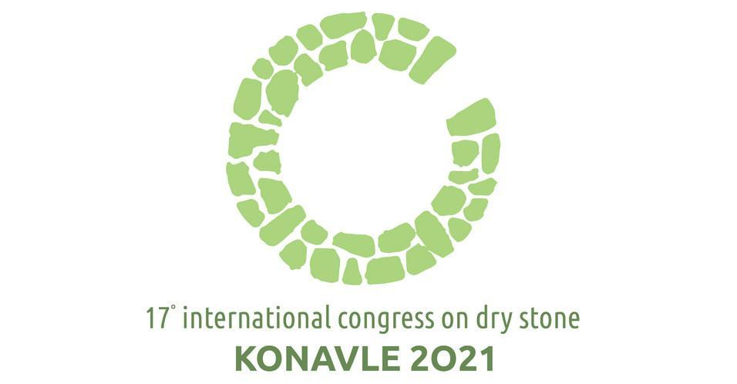

Workshop: September 27th - 30th 2021
Congress: October 1st - 3rd 2021

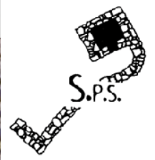
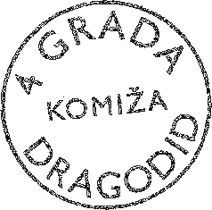
Please send the application filled out on the computer in Word format to contact@pierreseche-international.org and info@dragodid.org
Applications and participation fees

All interested can participate as listeners or workshop participants. Deadline for registering is July 31st 2021 and you can do it by sending a Registration form that contains more details (in attachment).
Participation fee covers: admittance to all sessions with simultaneous translation during presentations (Croatian, English, French), access to working documents, coffee and refreshments during breaks, welcome cocktail (Sep 30th), closing dinner (Oct 2nd), field trip (Oct 3rd).
It is possible to participate virtually, meaning that participants can present, listen to presentations and engage in discussion by a live stream. In this case, the participation fee for two Congress papers days (Oct 1st and Oct 2nd) is 80 EUR total and covers admittance to all sessions with simultaneous translation during presentations (Croatian, English, French), access to working documents.
Participating as a workshop participant only does not require paying the fee. Number of places for workshop participants is limited.

Fees in Euros are:
Participant (physically in Konavle): 80 EUR for 1 day or 170 EUR for three days
Participant (virtually by live stream): 80 EUR for 2 days
Decreased fees for members of SPS and students who will participate physically in Konavle:
 | 1 DAY | 3 DAYS
SPS member* | 50 | 140
SPS member* student | 50 | 80
Student | 80 | 120

* An SPS member that is a legal entity can use the decreased fee (50/140, or 50/80) for only two of its representatives. All other representatives of entities that are members of the S.P.S. pay the full fee (80/170, or 80/120).

Payment details: All fees are to be paid in Euros while registering, by bank account, with payment description: Congress fee - [name surname]

For SPS members:
Recipient: Société Internationale Etude Pierre Sèche
Crédit Agricole Mutuel de Provence Alpes Côte d’Azur, Brignoles, France
IBAN: FR76 1910 6000 0208 0610 8000 860 (BIC: AGRIFRPP891)
For participants who are not SPS members:
Recipient:
4 GRADA DRAGODID, Šapjane 23, Šapjane, Croatia
IBAN: HR0524070001100643928 (OTP bank)
SWIFT (BIC): OTPVHR2X
NOTE: the S.P.S. membership fee (40€ for the two years) is to be paid to the S.P.S. bank account.
Participant information

Please fill out all the fields.

- Name and surname:
- Full physical address (street, number, town, country):
- Representing organisation
- if applicable:
- E-mail address:
- Phone:

- I wish to participate at the Congress as – mark with X:
Listener (physically in Konavle)
Listener (virtually by live stream)
Workshop participant

- I wish to participate at these Congress events – mark with X:
Monday, Sep 27th - Thursday, Sep 30th International dry stone workshop
Friday, Oct 1st - Saturday, Oct 2nd Papers
Sunday, Oct 3rd Thematic visit: dry stone in Konavle

Registered participants who paid the participation fee will be contacted to announce their arrival and departure details. Organisers will send them the final program along with all necessary travel and accommodation information.

S.P.S. membership - existing and interested members
All interested persons and organisations can become members of International scientific society for dry stone interdisciplinary study S.D.S - Société Scientifique Internationale pour l'Étude Pluridisciplinaire de la Pierre Sèche S.P.S.
Website with more information: http://pierreseche-international.org/
S.P.S. subsists thanks to the membership fees: 40 Euros renewable every two years, coinciding with the congresses, which is also when the General Assembly is held. For this purpose, the Affiliation Form to join S.P.S. is attached here. The payment of this fee can be made by bank transfer to:

Société Internationale Etude Pierre Sèche
Crédit Agricole Mutuel de Provence Alpes Cote d’Azur, Brignoles, France
IBAN: FR76 1910 6000 0208 0610 8000 860
BIC: AGRIFRPP891

Affiliation form

- Name and surname:
- Full physical address (street, number, town, country):
- E-mail address:
- Phone:

I will pay my S.P.S. membership, period of 2020-2022: 40 EUR
I will pay my S.P.S. membership, as a student, period of 2020-2022: 20 EUR

Date and signature:

